SYCOTAᐩ Brand Guidelines
(Everything specified here is up for change.)

Introduction

Our Story
SYCOTAᐩ started out as a simple thought - what if we could make modern shooting systems accessible and affordable? What started as a simple idea - to create a more accessible and intuitive target evolved into a complex system that works for everyone, everywhere. From early models, every detail was designed with one goal in mind: helping people improve their aim, consistency and confidence, all while remaining within reach for everyone. We believe that precision isn’t just about hitting the center, but rather constant progress, learning and mastering control.

Our Vision
Our purpose is to redefine how people experience training and precision through accessible, smart technology. We aim to help the sport grow by making intelligent shooting systems affordable and available to everyone. We believe technology should empower, not exclude - which is why we design our systems to combine professional-grade accuracy with effortless usability, ensuring that precision training is within reach for people everywhere in the world.

Our Mission
To develop innovative, high-quality shooting systems that make precision training simple, accessible, and effective is our DNA. We focus on combining modern engineering with intuitive design to create reliable tools that empower users to improve their skills and confidence. Through continuous innovation and community-driven development, we strive to make advanced training experiences available to everyone - supporting the growth of the sport and the people who love it.

The Plus
The plus stands for inclusivity and accessibility. It speaks out that everyone can use it, no matter where they are, what they are and who they are.

Brand Personality
Our brand is: Accessible; Effective; Simple; Intuitive; Community; Bonding; For everyone, everywhere
Our brand is not: Luxury, Forced, Complicated, Expensive, Confusing, Complicated

Color Palette
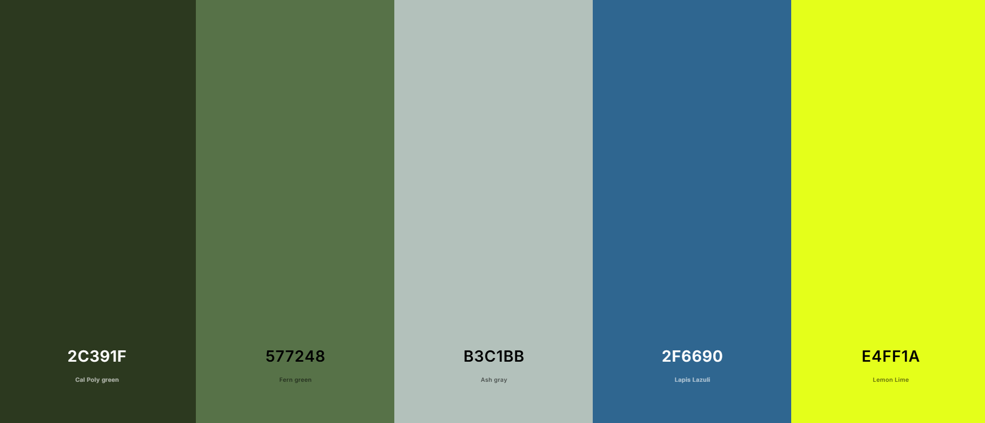
2C391F - Background
577248 - Background
B3C1BB - Background
2F6690 - Accent
E4FF1A - Accent

Brand Fonts
Logo: Poppins (Weight 600 Semi-Bold)
Headers: Inter
Paragraphs: Open Sans

Plus Symbol and Logo as Text
The SYCOTAᐩ name should always have the ᐩ (U+1459) next to it. Things such as “SYCOTA”, “SYCOTA+” are not allowed. Including that, when the name is spelled out as text, it should always be capitalized and retain the Poppins font. Try to avoid using it as text and always try to embed it as an image.

